GENEALOGY FROM ADAM TO JESUS
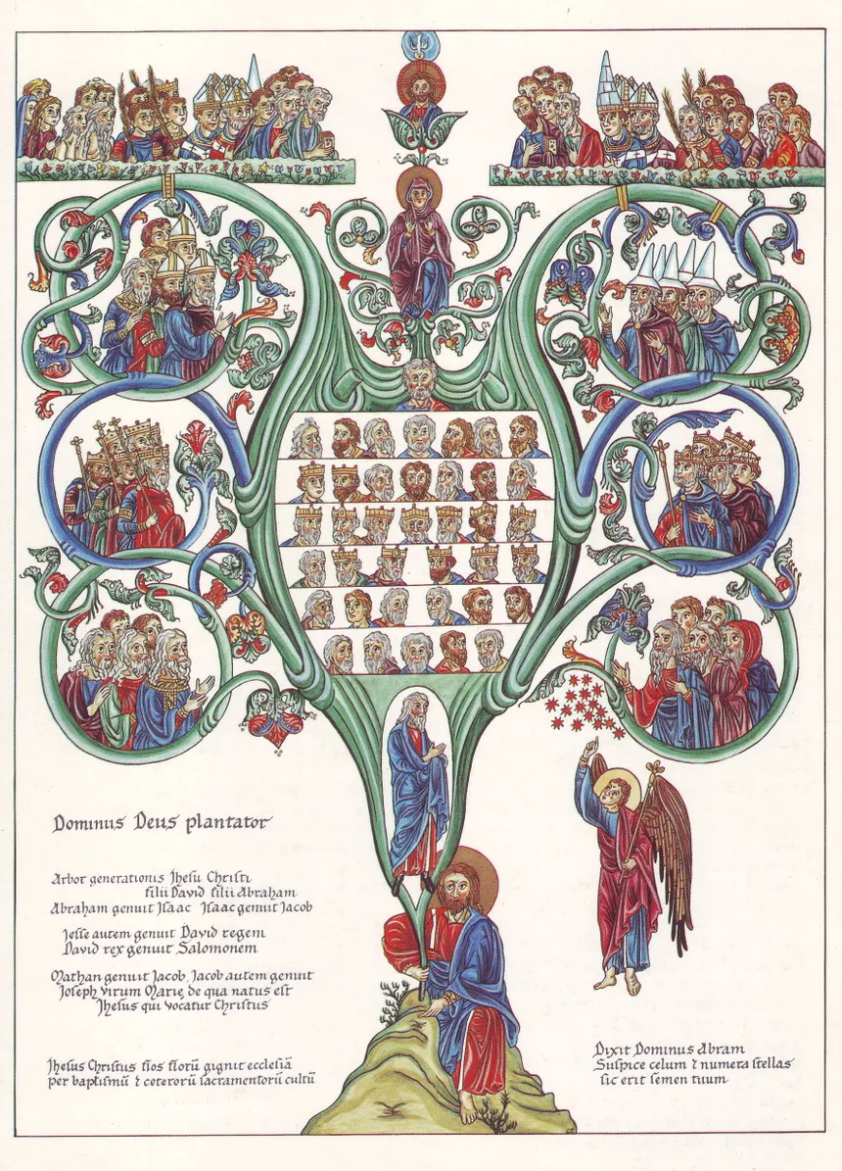

The dating system used here starts with the creation as year zero. Biblical chronology is the academic study of the dating of events in the Hebrew Bible.

In the New Testament the lineage of Jesus is traced by two of the Gospel writers, Matthew and Luke.

Luke describes the "generations of Christ" in Chapter 3 of Luke's Gospel, beginning with Jesus himself and tracing backwards through his "earthly father" Joseph all the way to Adam.

Matthew's Gospel opens with the words: The book of the generation of Jesus Christ, descendant of David, descendant of Abraham. With this beginning Matthew makes clear Jesus' whole lineage: - He is of God's chosen people, by his descent from Abraham, and he is the "shoot of Jesse" by his descent from Jesse's son, King David.

Section One - Adam to Noah

FIRST GENERATION

1. The earth was created on 25 March, 4001 BC. Adam, “First Man,” was created on Saturday the first day of Nisan in the year zero which was 31 March 4001 BC. Eve was more "made" than created so her date is unknown. She could have been formed on the sixth day or later. Adam and Eve were married that year in the Garden of Eden. Having been created by God to be perfect and to live for eternity they lost that position when they disobeyed God’s command. Because of their sin they were condemned to die. Adam and Eve were 130 years old when Seth was born. Adam died at the age of 930 years in the year 930.

Adam and Eve had the following sons plus other sons and daughters:

2. Cain. He killed his brother Abel and was banished. He married one of his sisters. [Gen 4:1-25] [Heb 11:4; 1John 3:12]
3. Abel. Dates for Cain and Able are unknown. [Gen 4:1-25] [Heb 11:4, 12:24;
Luke 11:51]
+4. Seth [Gen 4:25-26, 5:3-5:8; 1 Chr 1:1; Luke 3:38]

SECOND GENERATION

4. Seth was born in 130 and died in 1042. He was 105 years old when his son Enosh was born, and he died at the age of 912 years:
+5. Enosh or Enos [Gen 4:26-; 1 Chr 1] [Gen 5:6-11]

THIRD GENERATION

5. Enosh was born in 235 and died in 1140. He was 90 years old when his son Kenan was born, and he died at the age of 905 years:
+6. Kenan (a.k.a Cainan) [Gen 5:9-4; 1 Chr 1:2]

FOURTH GENERATION

6. Kenan or Cainan, "Wise King and Prophet," was born in 325. He was 70 years old when his son Mahalalel was born, and he died in 1235 at the age of 910:
+7. Mahalalel or Mahalaleel [Gen 5:12-17; 1 Chr 1:2; Neh 11:4]

FIFTH GENERATION

7. Mahalale or Mahalaleel was born in 395. He was 65 when his son Jared was born, and he died in 1290 at the age of 895.
+8. Jared. [Gen 5:15-20; 1 Chr 1:2; Luke 3:37]

SIXTH GENERATION

8. Jared, son of Mahalaleel, was born in 460. He was 162 when his son Enoch was born, and he died in 1422 at the age of 962.
+9. Enoch. [Gen 4:17-18, 5:18-24; 1 Chr 1:3; Luke 3:37; Heb 11:5; Jude 1:14]

SEVENTH GENERATION

9. Enoch, the Prophet, was born in 622. He was 65 when Methuselah was born, and he did not die but was taken up into heaven in 987 at the age of 365 years.
+10. Methuselah. [Gen 5:21-27; 1 Chr 1:3; Luke 3:37]

EIGHTH GENERATION

10. Methuselah was born in 687. He was 187 years old when Lamech was born and he died in 1656, the year of the flood, at the age of 969 years. He was the longest living man.
+11. Lamech. [Gen 4:18-24; 5:25-31; 1 Chr 1:3; Luke 3:36]

NINTH GENERATION

11. Lamech was born in 874. He was 182 when his son Noah was born, and he died in 1651 at the age of 777 years.
+12. Noah. [Gen 5:1, 29-32, 6:8-22, 7:1-23, 8:1-20, 9:1-29, 10:1-32; Num 26:33, 27:1, 36:11; Josh 17:3; 1 Chr 1:4; Isa 54:9; Ez 14:14-20] NT: [Matt 24:37-38; Luke 3:36, 17:26-27; Heb 11:7; 1 Pet 3:20; 2 Pety 2:5]

Section Two - Noah to Abraham

TENTH GENERATION

12. Noah, "of the Ark," was born in 1056. Noah was 502 years old when Shem was born, and he died in 2006 at the age of 950 years. During the time from Adam to Noah there was a tremendous increase in wickedness in the world. God decided to destroy the civilization of that day and build another one from Noah’s family. God commanded Noah to build a three-deck boat to save his family and animals from the worldwide flood. Only Noah, his wife, his three sons, and their wives were saved. The flood occurred in the year 1656 when Noah was 600 years old. According to Jewish tradition, Noah was married to Naamah the daughter of Lemach and Zillah, of the descendants of Cain (#2). Her brother was Tubal-Cain, a worker of bronze and iron.

Noah and Naamah had the following children:
+13. Japheth. [Gen 5:32, 6:10, 7:13, 9:18-27, 10:1-2, 21; 1Chr 1:4-5]
+14. Ham. [Gen 5:32, 6:10, 7:13, 9:18-22, 10:1, 6, 18, 20; 14:5; 1 Chr 1:4, 8; 4:40]
+15. Shem. [Gen 5:32, 6:10, 7:13, 9:18-27; 10:1, 21-22, 31; 11:10-11]

ELEVENTH GENERATION

15. Shem, Melchizedek, "Great High Priest" King of Salem, was born in 1558. Shem was 98 at the time of the flood in 1656. He was 100 when Arphaxad was born and died in 2158 at the age of 600 years. He had the following children:
16. Elam, born in 1658. [Gen 10:22]
17. Asshur, born in 1659. [Gen 10:11]
+18. Arphaxad. [Gen 10:22]
19. Lud. [Gen 10:13]
+20. Aram. [Gen 10:22]

TWELFTH GENERATION

18. Arphaxad, the son of Shem, "1st born after the flood," King of Arrapachtis, was born in 1658 in Shinar. He was 35 when his son Shelah was born, and he died in 2096 at the age of 438 years. + ** Cainan [Gen 5:9] +19. Shelah [Gen 38:5}

THIRTEENTH GENERATION

** Cainan is listed in Luke’s genealogy as the son of Araphaxad and the father of Shelah but he is not listed in the Hebrew text of the Old Testament. He is listed in the Septuagint Version which is the Greek translation of the Old Testament. At the present time it is impossible to know how this name came to be listed. Was it accidentally added or dropped by the copiers of the text?

19. Shelah or Salah, "Patriarch" King, was born in 1693 in Shinar. He was 30 when his son Eber was born and he died in 2126 in Shinar at the age of 433 years.
He had the following son:
+20. Eber. [Gen 10:21]

FOURTEENTH GENERATION

20. Eber or Heber, "Patriarch" King, was born in 1723 in Shinar. During his lifetime God confused the languages and the people were divided. He was 34 when Peleg was born whose name means divided. The word “Hebrew” comes from Eber for he was the father of the Hebrew race. He died in 2187 in Shinar at the age of 464 years.
+21. Peleg. [Gen 10:25]
+22. Joktan. [Gen 10:25]

FIFTEENTH GENERATION

21. Peleg, "Earth was divided" King, was born in 1757 in Shinar. He was 30 when Reu was born, and he died in 1996 in Mesha at the age of 239 years. Peleg's birth in 1757 dates to the tower of Babel.
+23. Reu. [Gen 11:18]

SIXTEENTH GENERATION

23. Reu, King of Lagash, was born in 1787 in Mesha. He was 32 when his son Serug was born. He lived for 239 years and died in 2026 in Mesha.
+24. Serug. [Gen 11:20]

SEVENTEENTH GENERATION

24. Serug, King of Ur & Agade, was born in 1819 in Mesha. He was 30 when his son Nahor was born. He lived to be 230 years old and died in 2049 in Mesha.
+25. Nahor. [Gen 11:22-26]

EIGHTEENTH GENERATION

25. Nahor, King of Ur & Agade, was born in 1849 in Ur of Chaldea. He was 29 when Terah was born, and he lived to be 148 years old, and he died in 1997 in Ur of Chaldea. +26. Terah.

Terah Chart

Because of much intermarriage within Terah's (# 26) family it is difficult to follow the relationships between his descendants. This chart shows the marriages between the various members and how they are related.

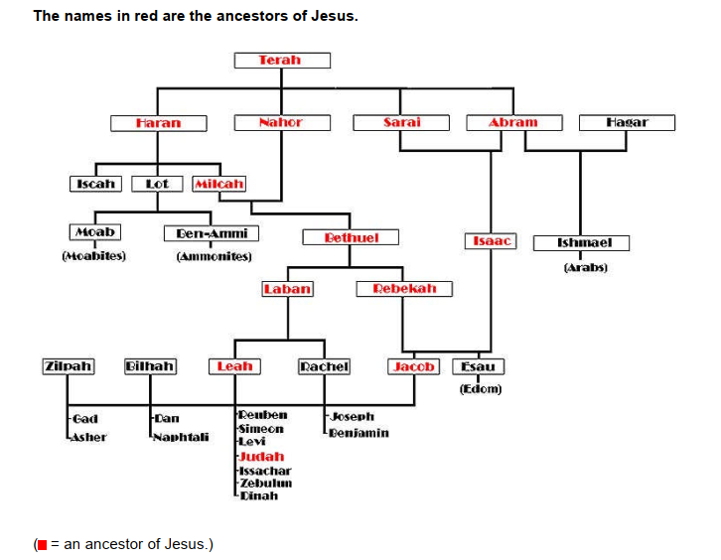

NINETEENTH GENERATION

26. Terah [Gen 11:27-32], "Patriarch" King of Agade, was born in 1878 in Ur of Chaldea. He was 70 when Abram, his youngest son, was born. He lived to the age of 205 years and died in 2083 in Ur of Chaldea.
He had the following children.
+27. Haran. [Gen 11:26]
+28. Nahor. [Gen 11:22-26]
+29. Abram (Abraham). [Gen 12:1-3]
+30. Sarai (f) (Sarah). [Gen 11:29]

Section Three - Abraham to David

20TH GENERATION.

27. Haran was born in Ur of Chaldea. He had the following children and died in Ur of Chaldea.
31. Iscah [Gen 11:29] was born in Ur of Chaldea and died there.
+32. Lot. [Gen 11:27]
33. Milcah (f). [Gen 11:29]

28. Nahor was born and died in Ur of Chaldea. He was married to Milcah (# 33) his niece and the daughter of Haran (#27) in Ur of Chaldea. She was born and died in Ur of Chaldea. Nahor and Milcah had the following children, all born in Ur, Chaldea:
34. Uz. [Gen 10:23]
34. Buz. [Gen 22:21]
35. Kemuel. [Gen 22:21]
36. Kesed. [Gen 22:22 - mentioned only once]
37. Hazo. [Gen 22:22]
38. Pildash. [Gen 22:22]
39. Jidlaph. [Gen 22:22]
+40. Bethuel. [Gen 22:22]

29. Abram (Abraham), “Father of Nations,” was born in 1948 in Ur of Chaldea. He immigrated in 2025 to Canaan. He died in 2123 in Hebron, Canaan. He was buried in the Cave of Machpelah near Mamre. Abraham was 100 years old when Isaac was born and he died at the age of 175 years. He married Sarai (Sarah) (# 30) who was born in 1958 in Ur of Chaldea. Her father was Terah (#26) and she was a half sister of Abraham. She died in 2085 in Kiriath Arba (Hebron), Canaan. She was buried in the Cave of Machpelah near Mamre. She lived to be 127 years old.

Abraham and Sarah had the following son:
+41. Isaac. [Gen 21:1-7]

Abraham had a son by Hagar, Sarai’s handmaiden, who was born in Egypt. Abram (Abraham)

and Hagar had the following son:
42. Ishmael. [Gen 16:11}

Abraham also married Keturah, and they had the following children all born in Beersheba, Canaan:
43. Zimran. [Gen 25:2]
+44. Jokshan. [Gen 25:2]
45. Medan. [Gen 25:2]
+46. Midian. [Gen 25:2]
47. Ishbak. [Gen 25:2]
48. Shuah. [Gen 25:2]

21ST GENERATION.

40. Bethuel was born in Ur of Chaldea. He died in Paddan Aram, Aramea and had the following children:
+49. Laban. [Gen 24:29]
50. Rebekah. [Gen 22:23]

41. Isaac, "Patriarch," was born in 2048 in The Negev, Canaan. He died in 2228 in Mamre (Hebron), Canaan at the age of 180 years. He was buried in the Cave of Machpelah near Mamre. He married Rebekah (# 50) the daughter of Bethuel (# 40) in 2090 in Canaan. Rebekah was born in Paddan Aram, Aramea. She died in Canaan and was buried in the Cave of Machpelah near Mamre.

Isaac and Rebekah had twin sons:
51. Esau. [Gen 25:19]
+52. Jacob. [Gen 25:19]

22ND GENERATION.

49. Laban, the son of Bethuel, was born and died in Paddan Aram, Aramea.
He had the following two daughters plus other sons:
+53. Leah. [Gen 29:1]
54. Rachel. [Gen 29:1]

52. Jacob “Israel Prophet,” was born in 2108 in Beer Lahai Roi, Canaan. He died in 2255 at the age of 147 years in Goshen, Egypt. He was buried in 2257 in the Cave of Machpelah near Mamre. He was around 49 years old when his first son Reuben was born. He first married Leah (# 53) the daughter of Laban (# 49) in Paddan Aram, Aramea. She was born in Paddan Aram, Aramea and died in Canaan. She was buried in the Cave of Machpelah near Mamre.
Jacob and Leah had the following six sons and one daughter:
55. Reuben. [Gen 29:32]
56. Simeon. [Gen 29:33]
57. Levi. [Gen 29:34]
+58. Judah. [Gen 29:34]
59. Issachar. [Gen 30:18
60. Zebulum. [Gen 49:13]
61. Dinah. [Gen 30:21]

Jacob also married Rachel (# 54) the daughter of Laban (# 49) in Paddan Aram, Aramea. She was born in Paddan Aram, Aramea and died near Bethlehem.
Jacob and Rachel had the following children:
62. Joseph. [Gen 30:24]
63. Benjamin. [Gen 35:18]

Jacob also married Bilhah, and they had the following sons:
64. Dan. [Gen 30:6]
65. Naphtali. [Gen 30:18]

Jacob also married Zilpah, and they had the following sons:
66. Gad. [Gen 30:11]
67. Asher. [Gen 30:13]

23RD GENERATION

58. Judah was born in Paddan Aram, Aramea and died in Egypt.
He had the following children:
68. Er was born in Kezib, Canaan. He died in Kezib, Canaan.
69. Onan was born in Kezib, Canaan. He died in Kezib, Canaan.
70. Shelah was born in Kezib, Canaan. He died in Goshen, Egypt.

Judah had twin sons by Tamar who was born in Canaan.

Their sons were:
71. Pharez or Perez. [Gen 38:29]
72. Zerah [Gen 36:13] they were born in Enaim, Canaan. Zerah died in Goshen, Egypt.

24TH GENERATION.

71. Pharez or Perez was born in Enaim, Canaan. He died in Goshen, Egypt.
He had the following children:
+73. Hezron. [Gen 46:9]
74. Hamul [Gen 46:12] was born in Canaan. He died in Goshen, Egypt.

25TH GENERATION

73. Hezron or Esrom or Chezron was born in Canaan. He died in Goshen, Egypt.
He had the following son:
+75. Ram or Aram [Gen 10:22], son of Hezron.

26TH GENERATION.

75. Ram or Aram, son of Hezron, was born in Egypt. He died in Egypt.
He had the following son:
+76 Amminadab [Ex 6:23]

27TH GENERATION.

76 Amminadab, son of Ram, was born in Egypt.
He had the following son:
+77. Nahshon or Naasson. [Ex 6:23]

28TH GENERATION.

77. Nahshon or Naasson was born in Egypt. He died in the Wilderness of Paran. He was the prince of the tribe of Judah during the journey through the wilderness. He had the following son:
+78. Salma or Salmon. [1Chr 2:51]

29TH GENERATION.

78. Salma or Salmon was born in the Wilderness and died in Bethlehem. He was married to Rahab who was born in Jericho. She died in Bethlehem. She saved the three spies of Israel who entered Jericho and as a result she and her family were saved from the destruction of Jericho.

Salma and Rahab had the following son:

+79. Boaz. [Ruth 2:1]

30TH GENERATION

79. Boaz was born in Bethlehem and died in Bethlehem. He was married to Ruth in Bethlehem. She was born in Moab and died in Bethlehem. She was a widow who moved from Moab to Bethelehm with Naomi her mother-in-law. Boaz and Ruth had the following son:
+80. Obed. [Ruth 4:17]

31ST GENERATION

80. Obed was born in Bethlehem and died in Bethlehem.
He had the following son:
+81. Jesse. [Ruth 4:17]

32ND GENERATION

81. Jesse was born in Bethlehem and probably died there.
He had the following children all born in Bethlehem:
82. Eliab. [Num 1:9]
83. Abinadab. [1Sam 7:1]
84. Shimea. [2Sam 13:3]
85. Nethanel. [Num 1:8]
86. Raddai. [1 Chr 2:14]
87. Ozem. [1 Chr 2:15]
+88. David. [Ruth 4:17-22]
89. Zeruiah a daughter [1Sam 26:6]
90. Abigail a daughter. [1Sam 25:1]

Section Four - From David to Jesus

33RD GENERATION

88. David, King of Israel, was born in Bethlehem in 2853 and died in Jerusalem in 2923 at the age of 70 or 71. He was 30 years old when he became king of Judah and reigned for seven- and one-half years in Hebron. Then he became king of all Israel in 2883 and reigned for 33 more years until 2923. He was a good king, an excellent organizer, a master musician and writer of many hymns. His one failure, the affair with Bathsheba, was a bad influence on his children who later caused him considerable trouble and heartache.

David first married Michal the daughter of Saul, King of Israel. They had no children.

David also married Ahinoam who was born in Jezreel. She died in Jerusalem. David and

Ahinoam had the following son:
89. Amnon, David’s first-born son, was born in Hebron. He died in Baal Hazor. He was murdered on Absalom's orders.

David also married Abigail, the widow of Nabal. She was born in Carmel and died in Jerusalem.

David and Abigail had the following son:
90. Daniel was born in Hebron. At first his name was Kileab but later it was changed to Daniel. No record is given of his later life.

David also married Maacah daughter of Talmai the King of Geshur. She was born in Geshur and died in Jerusalem.
David and Maacah had the following children:
+91. Absalom. [Gen 2Sam 3:3]
92. Tamar. [Gen 38:6]

David also married Haggith and had the following son:
93. Adonijah [2Sam 3:4] was born in Hebron. He died in Jerusalem. He was executed by the order of Solomon.

David also married Abital and had the following son.
94. Shephatiah [2Sam 3:4] was born in Hebron.

David also married Eglah and had the following son:
95. Ithream [2Sam 3:5] was born in Hebron.

88 David also married Bathsheba the widow of Uriah the Hittite. She was the daughter of Eliam and the granddaughter of Ahithophel one of David's counselors who took part in the rebellion of Absalom. Bathsheba came from Gilon and died in Jerusalem. David and Bathsheba had the following sons all born in Jerusalem:
96. Shammua. [Num 13:4]
97. Shobab. [2Sam 5:14]
+98. Nathan [2Sam 5:14]– Direct line of Mary, Mother of Jesus.
+99. Solomon. [2Sam 5:14]

34TH GENERATION

91. Absalom was born in Hebron. He died in Ephraim. His mother was the daughter of the king of Gesher. He had his servants kill his half-brother, Amnon (# 89). Later he rebelled against his father and tried to take the kingdom by force, but he died in a battle with the forces of King David. Absalom had three sons who did not survive him, and a daughter named Tamar. He also had a sister named Tamar. Another daughter is mentioned, named Maacah. Maacah and Tamar may be the same person who at first was called Tamar, after his sister, and later Maacah, after his mother.
+100. Maacah. [Gen 22:24] She married her cousin Rehoboam (# 102).

98. Nathan, the son of David and Bathsheba, was born in Jerusalem.

The decedents of Nathan are listed in the genealogy used by Luke in his life of Jesus.
This line, according to some, leads directly to Mary, the mother of Jesus.
He had the following son:
+101. Mattatha. [Luke 3:31]

99. Solomon, King of Israel, was born in 2899 and died in Jerusalem in 2963 at the age of 64. He was buried in the City of David. He reigned as King of Israel in Jerusalem for 40 years. He began as a wise king who built the temple, one of the marvels of the world. He also built many other buildings, gardens, enlarged and fortified several cities, and he had a large army. He had many wives who turned him away from God. He married Naamah who was born in Ammon. She died in Jerusalem.

Solomon and Naamah had the following son:
+102. Rehoboam. [Gen 1Kings 11:43]

35TH GENERATION

101 Mattatha. Of Nathan's line had the following son:
+103. Menna. [Luke 3:31]

102. Rehoboam, King of Judah, was born in Jerusalem in 2923 and died there in 2981 at the age of 58. Inflation and taxes were a burden on the nation when he began to reign. Because he followed bad advice the kingdom split into two parts and he reigned only over Judah the southern part of Israel. He was 41 years old when he became king and reigned for 17 years in Jerusalem. During his reign, Shishak, the king of Egypt, attacked Jerusalem and took much booty. He married his cousin Maacah (# 100) daughter of his uncle Absalom (# 91).
(He had eighteen wives, sixty concubines, twenty eight sons, and sixty daughters. His favorite wife was Maacah.)
Rehoboam and Maacah had the following son:
+104. Abijah. [1Sam 8:2]

36TH GENERATION

104. Abijah, King of Judah, was born in Jerusalem. He reigned for only 3 years in Jerusalem and died there in 2984. During his reign he was in a battle with Israel, the northern kingdom, and was outnumbered. He would have lost but the army called for help from God and they were victorious because they relied on the Lord, the God of their fathers.

He had several wives, sons, and daughters but Asa followed him as king.
+105. Asa. [2Sam 2:18]

103. Menna of Nathan’s line had the following son:
+106. Melea. [Luke 3:31]

37TH GENERATION

105. Asa, King of Judah, was born in Jerusalem and died there. He reigned for 41 years in Jerusalem. He was a righteous ruler removing the foreign alters and idols. During his time a very large army from Cush attacked Judah so Asa called upon God for help and was victorious. The men of Judah carried off a large amount of plunder. He married Azubah and had the following son.
+107. Jehoshaphat. [Gen 2Sam 8:16]

106. Melea of Nathan's line had the following son:
+108. Eliakim. [2Kings 18:18]

38TH GENERATION

107. Jehoshaphat, King of Judah, was born in 2990 in Jerusalem and died there. He was 35 years old when he became king and reigned for 25 years in Jerusalem from 3025 to 3050. He was a good king sending priests throughout the land to teach the people the Law of God. He made one serious mistake in making an alliance with the kings of Israel who were wicked rulers. He had seven sons of whom Jehoram was the firstborn who became king at his death.
+109. Jehoram. [1 Kings 22:50]

108. Eliakim of Nathan's line had the following son:
+110. Jonam. [Luke 3:30]

39TH GENERATION

109. Jehoram or Joram, King of Judah, was born and died in Jerusalem. He was 32 years old when he became king and reigned for 8 years from 3047 to 3054. He followed the example of the kings of Israel so was a wicked ruler. The first thing he did was to kill all his brothers then he married Athaliah, a daughter of Ahab a very wicked king of Israel. He did not have the protection of God so was attacked by many enemies who killed all of his sons except Ahaziah his youngest son. Jehoram died to no one's regret, and he was buried in the City of David, but not in the tombs of the kings.

Jehoram and Athaliah had the following son:
+111. Ahaziah. [1Kings 22:40]

110. Jonam of Nathan's line had the following son:
+112. Joshua. [Ex 17:9]

40TH GENERATION

111. Ahaziah, King of Judah, was born in Jerusalem and was buried there. He was 22 years old when he became king and reigned one year in Jerusalem from 3054 to 3055. His mother, Athaliah, encouraged him to do wrong. He was wounded by Jehu at Jezreel. He fled to Megiddo where he died and his body was taken to Jerusalem and buried in the City of David. He married Zibiah who was born in Beersheba, Canaan. She died in Jerusalem.

Ahaziah and Zibiah had the following son:
+113. Joash. [Judges 6:11]

112.Joshua of Nathan's line had the following son:
+114. Er. [Gen 38:3]`

* When Ahaziah died, his mother, Athaliah, killed all the royal princes except for Joash (#113) the youngest and put herself up as ruler. Joash (#113) was saved by an aunt and hidden in the temple buildings until he was seven years old. At that time, he was proclaimed king and Athaliah was killed. She ruled for seven years from 3055 to 3061.

41ST GENERATION

113. Joash, King of Judah was born in Jerusalem. He died in Beth Millo and was buried in Jerusalem. Joash was 7 years old when he became the king of Judah in 3061 and he reigned in Jerusalem for 40 years until 3101. He started out as a good king but when the high priest who had raised him died, he followed worthless men and turned bad. He was assassinated at Beth Millo by his officers. He married Jehoaddin who was born in Jerusalem and died there. Joash and Jehoaddin had the following son:
+115. Amaziah. [2Kings 12:21]

114. Er. Of Nathan's line had the following son:
+116. Elmadam. [Luke 3:28]

42ND GENERATION

115. Amaziah, King of Judah, was born in Jerusalem. He was 25 years old when he became king and reigned for 29 years from 3100 to 3129. They conspired against him in Jerusalem, he fled to Lachish where he was killed and his body was returned to Jerusalem where he was buried. He married Jecoliah who was born in Jerusalem and died there. Amaziah and Jecoliah had the following son:
+117. Azariah, [1 Kings 4:2] also called Uzziah.

116.Elmadam of Nathan's line had the following son:
+118. Cosam. [Luke 3:28]

43RD GENERATION

117. Azariah or Uzziah, King of Judah, was born in Jerusalem and died there. He became king of Judah at age 16 and reigned for 52 years from 3117 to 3168. He married Jerusha (daughter of Zadok) who died in Jerusalem. He was a good king but became proud and tried to offer incense in the temple where only the priests were allowed to go. Because of his actions leprosy broke out on his forehead and he was forced to live the rest of his life in a separate building.

Azariah (Uzziah) and Jerusha had the following son:
+119. Jotham. [Judges 9:5]

118. Cosam of Nathan's line had the following son:
+120. Addi. [Num 5:7]

44TH GENERATION

119. Jotham, King of Judah, was born in Jerusalem and died there. He began to reign at age 25 and reigned in Jerusalem for 16 years from 3168 to 3184. He did what was right in God's sight and he grew powerful because he was faithful before the Lord his God. He had the following son:
+121. Ahaz. [1 Kings 22:40]

120. Addi of Nathan's line had the following son:
+122. Melki. [Luke 3:28]

45TH GENERATION

121. Ahaz, King of Judah, was born in Jerusalem and died there. Ahaz was 20 years old when he became king and reigned in Jerusalem for 16 years from 3184 to 3200. He was a wicked king who worshipped idols and sacrificed his sons in fire to false gods. Because he was not faithful to God he was defeated in all his battles, with heavy losses. He married Abijah and had the following son:
+123. Hezekiah. [2Kings 16:20]

122. Melki of Nathan's line had the following son:
+124. Neri. [Luke 3:27]

46TH GENERATION

123. Hezekiah, King of Judah, was born in Jerusalem and died there. He was 25 years old when he became king and reigned in Jerusalem for 29 years from 3200 to 3229. He was one of the better kings with a great faith in God. He lived during the time of Isaiah who told him he was about to die. God heard his prayers and healed him.

He married Hephzibah and had the following son.
+125. Manasseh. [2 Kings 21:1-18; 2 Chr 33:1-20]

124. Neri of Nathan's line had the following son:
+126. Shealtiel. [1Chr 3:17]

Mathew’s version shows Shealtiel (# 136) is the son of Jechoniah (# 134).

47TH GENERATION

125. Manasseh, King of Judah, was born in Jerusalem and died there. He was 12 years old when he became king and reigned 55 years in Jerusalem from 3229 to 3284. He was the most evil of the kings of Judah. He married Meshullemeth from Jotbah, the daughter of Haruz. She died in Jerusalem.

Manasseh and Meshullemeth had the following son:
+127. Amon. [2 Kings 21:1-26]

126. Shealtiel of Nathan's line had the following son:
+128. Zerubbabel or Zorobable. [1 Chr 3:17]

Luke’s version shows Shealtiel’s (# 126) father is Neri (# 124).
Mathew’s version shows Shealtiel’s (# 136) father is Jechoniah or Jehoichin (# 134).
Mathew’s version shows Shealtiel (# 136) also had a son, Zerubbabel or Zorobable (# 138).

48TH GENERATION

127. Amon, King of Judah, was born in Jerusalem and died there. He was 22 years old when he became king and reigned for 2 years in Jerusalem from 3284 to 3286. His officers conspired against him and assassinated him in his palace. He was buried in the garden of Uzza. He married Jedidah from Bozkath the daughter of Adaiah. She died in Jerusalem.
Amon and Jedidah had the following son:
+129. Josiah. [2 Kings 22:8-13]

128. Zerubbabel or Zorobable of Nathan's line had the following son:
+130. Rhesa. [Luke 3:27] This line carries on through Joanan (# 133)

Mathew’s version shows Zerubbabel or Zorobable (# 136) had another son:
+140. Abiud. [Matt 1:13] This line carries on through Eliakim (# 142)

49TH GENERATION

129. Josiah, King of Judah, was born in Jerusalem. He was 8 years old when he became king and reigned 31 years in Jerusalem from 3286 to 3317. He died in a battle against Pharaoh Neco of Egypt at Megiddo and was buried in Jerusalem. He married Zebidah (daughter of Pedaiah) who was born in Rumah.

Josiah and Zebidah had the following son:
+131. Jehoiakim or Eliakim. [2 Kings 23:34]

Josiah also married Hamutal (daughter of Jeremiah) who was born in Libnah. Josiah and Hamutal had the following son:

132. Jehoahaz was born in Jerusalem. He died in Egypt. He became king of Judah and reigned in 3317

130. Rhesa of Nathan's line had the following son:
+133. Joanan.

50TH GENERATION

131. Jehoiakim or Eliakim, King of Judah, was born in Jerusalem. He died in Babylon. Pharaoh Neco put Eliakim on the throne of Judah and changed his name to Jehoiakim. He was 25 when he began to reign. He was on the throne for 11 years from 3317 to 3327, when Nebuchadnezzar took him captive to Babylon. He married Nehushta (daughter of Elnathan) who was born in Jerusalem and died in Babylon.

Jehoiakim and Nehushta had the following son:
+134. Jechoniah or Jehoichin.

133. Joanan of Nathan's line had the following son:
+135. Joda.

51ST GENERATION

134. Jechoniah or Jehoichin, King of Judah was born in Jerusalem and died in Babylon. He was 18 when he became king of Judah and reigned for three months and 10 days in 3327. Nebuchadnezzar then forced him to go to Babylon. He had the following son.
+136. Shealtiel or Salathiel.

Luke’s version shows Shealtiel (# 126) is the son of Neri (# 124).

135.Joda of Nathan's line had the following son:
+137. Josech.

52ND GENERATION

136. Shealtiel or Salathiel. Luke’s version shows his father as Neri (# 124). Mathew’s version shows his father as Jechoniah or Jehoichin (# 134).
Both show him having the following son:
+138. Zerubbabel or Zorobable.

137. Josech of Nathan's line had the following son:
+139. Semein.

53RD GENERATION

138. Zerubbabel or Zorobable.
Mathew’s version shows Zerubbabel or Zorobable had the following son:
+140. Abiud. This line carries on through Eliakim (# 142)
Luke’s version shows Zerubbabel or Zorobable (# 128) had another son, Rhesa (# 130). This line follows Nathan’s line through Joanan (# 133).

139. Semein of Nathan's line had the following son:
+141. Mattathias.

54TH GENERATION

140. Abiud had the following son:
+142. Eliakim.

141. Mattathias of Nathan's line had the following son:
+143. Maath.

55TH GENERATION

142. Eliakim had the following son:
+144. Azor.

143.Maath of Nathan's line had the following son:
+145. Naggai.

56TH GENERATION

144. Azor had the following son:
+146. Zadok.

145. Naggai of Nathan's line had the following son:
+147. Esli.

57TH GENERATION

146. Zadok had the following son:
+148. Akim.

147. Esli of Nathan's line had the following son:
+149. Nahum.

58TH GENERATION

148. Akim had the following son:
+150. Eliud.

149.Nahum of Nathan's line had the following son:
+151. Amos.

59TH GENERATION

150. Eliud had the following son:
+152. Eleazer.

151. Amos of Nathan's line had the following son:
+153. Mattathias.

60TH GENERATION

152. Eleazer had the following son:
+154. Matthan.

152.Mattathias of Nathan's line had the following son:
+155. Joseph.

61ST GENERATION

154.Matthan had the following son:
+156. Jacob.

Christian tradition identifies a woman named Estha as the grandmother of Joseph (#185). She married Matthan, (#154) a descendant of David (#88) through Solomon (#99), and by him became the mother of Jacob (# 156).
However, after Matthan (#154) died, she remarried and by her second husband Matthat (#
167), a descendant of David (#88) through Nathan (#98), became the mother of Heli (#168).
Therefore, Jacob (# 156) and Heli (#168) are half-brothers who have the same mother.
Heli (#168) married but died without children. So, his widow undertook the ancient custom of a levirate marriage and married the brother Jacob (#156) to give her children in Heli's (#168) name. She birthed Joseph (#158).

Therefore, Joseph (#158) is both the biological son of Jacob (#156), from Solomon (#99) and the legal son of Heli (#168), from Nathan (# 98). Therefore, two genealogies have been preserved.

While being the legal son of Heli (#168), Joseph (#158) and his mother remained in the household of Jacob (#156), according to custom, and Joseph (#158) legally inherited from Jacob (#156).

155. Joseph of Nathan's line had the following son:
+157. Jannai.

62ND GENERATION

156. Jacob had the following son:
+158. Joseph "the Carpenter"

157. Jannai of Nathan's line had the following son:
+159. Melki.

63RD GENERATION

158. Joseph "the Carpenter" was born in 0094 BC in Bethlehem, Judea. He died 26 Oct 0017 at age 111. Joseph of the line of Solomon was the legal father of Jesus (# 170). He married Mary "the Virgin" and "Our Lady" (# 200) about Oct 0002 BC in Bethlehem, Judea.

Before Joseph married Mary, he had two daughters and the following sons with another wife.
160. James the Less
161. Joseph
162. Simon
163. Judas,
The two daughters were:
164. Assia
165. Lydia

159. Melki of Nathan's line had the following son:
+166. Levi. [Gen 29:34]

64TH GENERATION

166. Levi of Nathan's line had the following son:
+167. Matthat. [Luke 3:24, 29]

65TH GENERATION

167. Matthat of Nathan's line had the following son:
+168. Heli or Eli. [1Sam 1:1, 3]

66TH GENERATION

168. Heli or Eli of Nathan's line had the following daughter:
+169. Mary, "the Virgin" and "Our Lady"

Widely accepted by later tradition, Joachim of the house of Amram; and Anne of David's house and line, were the parents of the Virgin Mary (# 169), according to Christian tradition. In spite of this, some speculate that Mary (# 169), like Joseph (# 158), to whom she was betrothed, was of the House of David and so of the tribe of Judah, and that the genealogy presented in Luke was hers, while Joseph's (# 158) is given in Matthew.

67TH GENERATION

169. Mary, "the Virgin" and "Our Lady" was born on 17 Jun 0016 BC in Nazareth, Galilee, Roman Empire. It is believed she died in 0048 at Jerusalem at age 64. Some believe she died at Ephesus, near Izmir at a place they call the Virgin Mary’s House. Others believe she died in Glastonbury (Avalon), Wessex, Britain (England), and she was buried in Our Lady's Dowry.

There are stories about Jesus accompanying Joseph of Arimathea to Glastonbury as a young boy.
Mary (# 169), a virgin, was empowered by the Holy Spirit.

She gave birth to Jesus, the Son of God (#170).

68TH GENERATION

170. Jesus, the Son of God was born on 6 Apr 0001 BC (Passover), in Bethlehem, Judea, Roman Empire. He died on 14 Apr 0033 age 33 (Passover), in Jerusalem, Judea, Roman Empire. He was buried on 17 Apr 0033 in the Tomb of Joseph of Arimathea, Golgotha, Judea, Roman Empire.

Jesus (# 170) was related to his father, Joseph (# 158), by adoption. He was the only begotten son of God. Some people believed Jesus (# 170) was the son of Joseph (# 158), but Luke’s version states that he was the son of Mary's (# 169) father Heli or Eli (# 168). Thus, Joseph (# 158) would be irrelevant to this genealogy.

It is believed he married Mary Magdalene. Mary Magdalene was born in Magdala (north of Tiberius near the Sea of Galilee). She died in Vézelay, Burgundy, Gaul (France).

GENEALOGY
Gen 4:16-22 CAIN
Gen 5:1-32 ADAM T NOAH
Gen 10 NOAH
Gen 11:10-32 SHEM
GEN 11:27-32 TERAH
Gen 22:20-24 NAHOR
Gen 25:1-4 ABRAHAM
Gen 25:12-16 ISHMAEL
Gen 35:23-29 JACOB
Gen 36:1-43 ESAU
Gen 46:8-27 ISRAEL
Ex 1:5 JACOB - 70
Ex 6:14-27 MOSES/AARON
Num 1:5-42 ISRAEL’S WARRIORS
Num 25:13-18 PHINEHAS
Num 26 ISRAEL
Joshua 21 LEVI
Ruth 4:18-22 PHAREZ TO DAVID
1 Chron 1:1-4 ADAM TO NOAH
1 Chron 1:4-27 NOAH TO ABRAHAM
1 Chron 1:28-31 ISHMAEL
1 Chron 1:32-33 ABRAHAM

1 Chron 1:35-54 ESAU
1 Chron 2 DAVID
1 chron 3 DAVID
1 chron 4 JUDAH, SIMEON
1 chron 5 REUBEN, GAD
MANASSEH
1 chron 6 LEVI
1 chron 7 ISSACHAR, BENJAMIN
NAPHTALI, MANASSEH
EPHRAIM, ASHER
1 chron 8 SAUL
1 chron 9 RETURNED EXILES
SAUL REPEATED
EZRA 2 EXILES RETURNED
Ezra 7:1-5; 8:1-14 CAPTIVE JEWS
ezra 10:18-44 intermarriage
Neh 7:5-65 LIST OF RETURNED EXILES
Neh 11 & 12 JERUSALEM/PRIESTS
Matt 1:1-16 JESUS
Luke 3:23-38 JESUS

1 Chronicles 1
English Standard Version

From Adam to Abraham
1 Adam, Seth, Enosh; ² Kenan, Mahalalel, Jared; ³ Enoch, Methuselah, Lamech; ⁴ Noah, Shem, Ham, and Japheth.
⁵ The sons of Japheth: Gomer, Magog, Madai, Javan, Tubal, Meshech, and Tiras. ⁶ The sons of Gomer: Ashkenaz, Riphath, and Togarmah. ⁷ The sons of Javan: Elishah, Tarshish, Kittim, and Rodanim.
⁸ The sons of Ham: Cush, Egypt, Put, and Canaan. ⁹ The sons of Cush: Seba, Havilah, Sabta, Raamah, and Sabteca. The sons of Raamah: Sheba and Dedan. ¹⁰ Cush fathered Nimrod. He was the first on earth to be a mighty man.
¹¹ Egypt fathered Ludim, Anamim, Lehabim, Naphtuhim, ¹² Pathrusim, Casluhim (from whom the Philistines came), and Caphtorim.
¹³ Canaan fathered Sidon his firstborn and Heth, ¹⁴ and the Jebusites, the Amorites, the Girgashites, ¹⁵ the Hivites, the Arkites, the Sinites, ¹⁶ the Arvadites, the Zemarites, and the Hamathites.
¹⁷ The sons of Shem: Elam, Asshur, Arpachshad, Lud, and Aram. And the sons of Aram: Uz, Hul, Gether, and Meshech. ¹⁸ Arpachshad fathered Shelah, and Shelah fathered Eber. ¹⁹ To Eber were born two sons: the name of the one was Peleg (for in his days the earth was divided), and his brother's name was Joktan. ²⁰ Joktan fathered Almodad, Sheleph, Hazarmaveth, Jerah, ²¹ Hadoram, Uzal, Diklah, ²² Obal, Abimael, Sheba, ²³ Ophir, Havilah, and Jobab; all these were the sons of Joktan.
²⁴ Shem, Arpachshad, Shelah; ²⁵ Eber, Peleg, Reu; ²⁶ Serug, Nahor, Terah; ²⁷ Abram, that is, Abraham.
From Abraham to Jacob
²⁸ The sons of Abraham: Isaac and Ishmael. ²⁹ These are their genealogies: the firstborn of Ishmael, Nebaioth, and Kedar, Adbeel, Mibsam, ³⁰ Mishma, Dumah, Massa, Hadad, Tema, ³¹ Jetur, Naphish, and Kedemah. These are the sons of Ishmael. ³² The sons of Keturah, Abraham's concubine: she bore Zimran, Jokshan, Medan, Midian, Ishbak, and Shuah. The sons of Jokshan: Sheba and Dedan. ³³ The sons of Midian: Ephah, Epher, Hanoch, Abida, and Eldaah. All these were the descendants of Keturah.
³⁴ Abraham fathered Isaac. The sons of Isaac: Esau and Israel. ³⁵ The sons of Esau: Eliphaz, Reuel, Jeush, Jalam, and Korah. ³⁶ The sons of Eliphaz: Teman, Omar, Zepho, Gatam, Kenaz, and of Timna, Amalek. ³⁷ The sons of Reuel: Nahath, Zerah, Shammah, and Mizzah.
³⁸ The sons of Seir: Lotan, Shobal, Zibeon, Anah, Dishon, Ezer, and Dishan. ³⁹ The sons of Lotan: Hori and Hemam; and Lotan's sister was Timna. ⁴⁰ The sons of Shobal: Alvan, Manahath, Ebal, Shepho, and Onam. The sons of Zibeon: Aiah and Anah. ⁴¹ The son of Anah: Dishon. The sons of Dishon: Hemdan, Eshban, Ithran, and Cheran. ⁴² The sons of Ezer: Bilhan, Zaavan, and Akan. The sons of Dishan: Uz and Aran.
⁴³ These are the kings who reigned in the land of Edom before any king reigned over the people of Israel: Bela the son of Beor, the name of his city being Dinhabah. ⁴⁴ Bela died, and Jobab the son of Zerah of Bozrah reigned in his place. ⁴⁵ Jobab died, and Husham of the land of the Temanites reigned in his place. ⁴⁶ Husham died, and Hadad the son of Bedad, who defeated Midian in the country of Moab, reigned in his place, the name of his city being Avith. ⁴⁷ Hadad died, and Samlah of Masrekah reigned in his place. ⁴⁸ Samlah died, and Shaul of Rehoboth on the Euphrates reigned in his place. ⁴⁹ Shaul died, and Baal-hanan, the son of Achbor, reigned in his place. ⁵⁰ Baal-hanan died, and Hadad reigned in his place, the name of his city being Pai; and his wife's name was Mehetabel, the daughter of Matred, the daughter of Mezahab. ⁵¹ And Hadad died.
The chiefs of Edom were: chiefs Timna, Alvah, Jetheth, ⁵² Oholibamah, Elah, Pinon, ⁵³ Kenaz, Teman, Mibzar, ⁵⁴ Magdiel, and Iram; these are the chiefs of Edom.
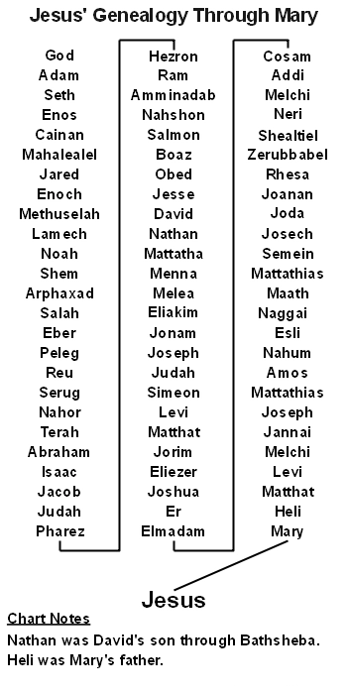 | 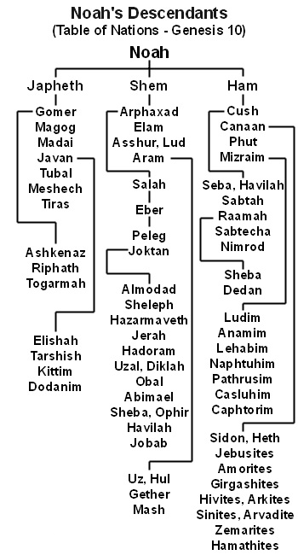
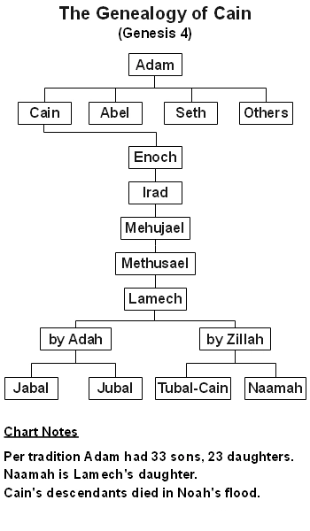 | 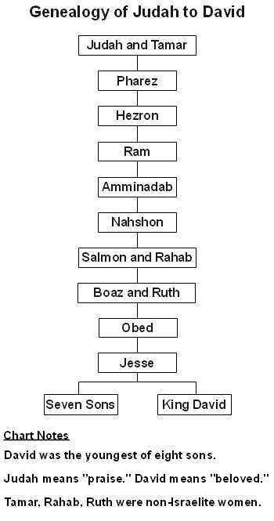
 | 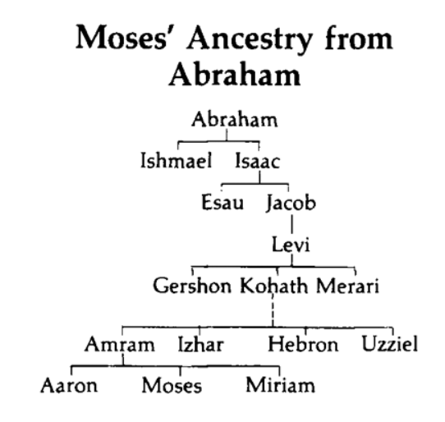
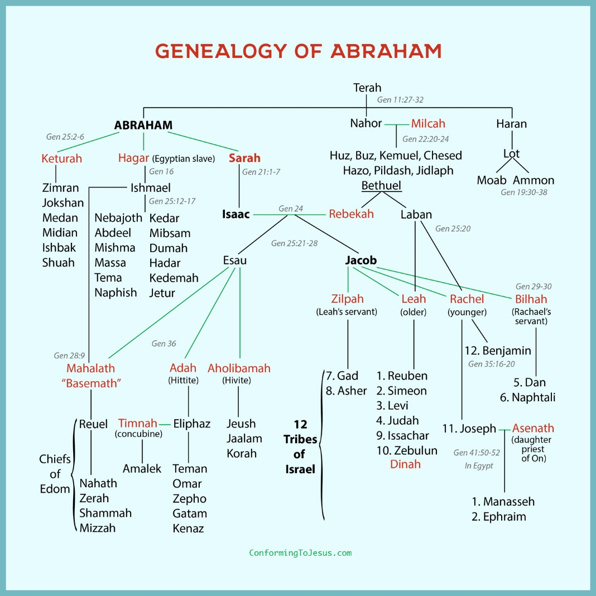
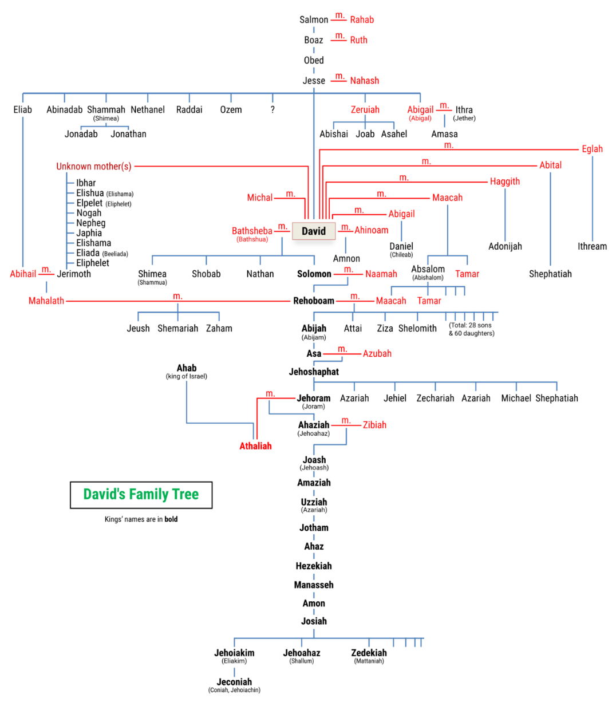
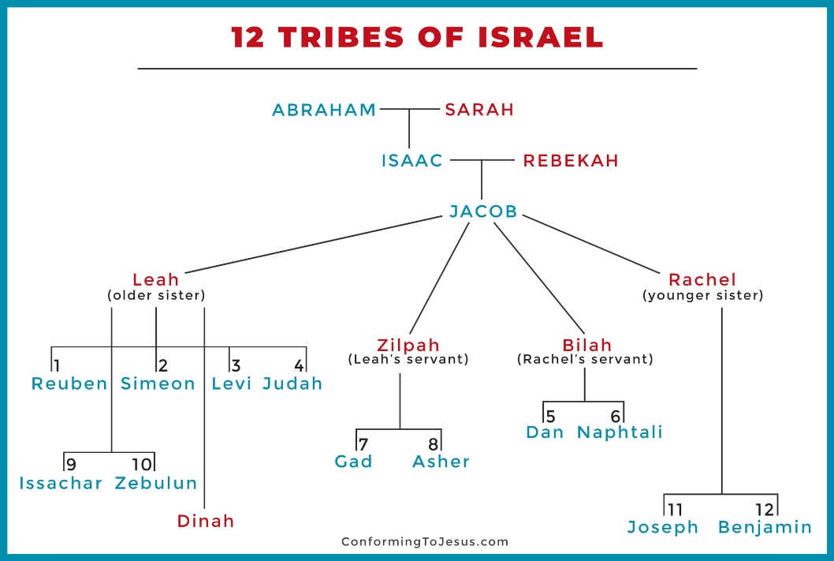
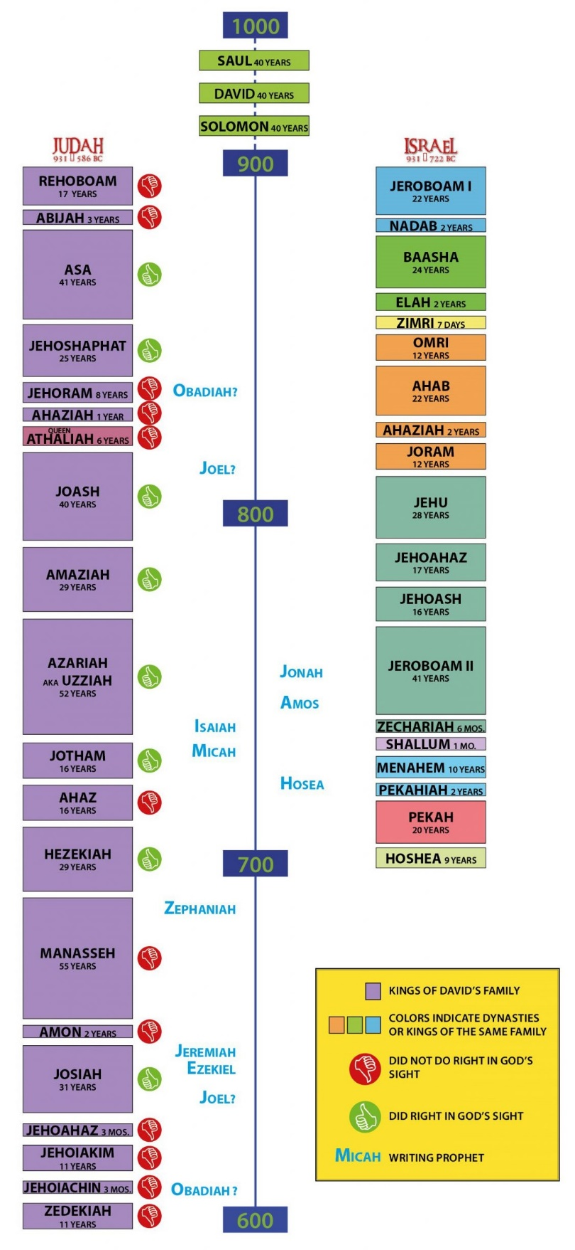
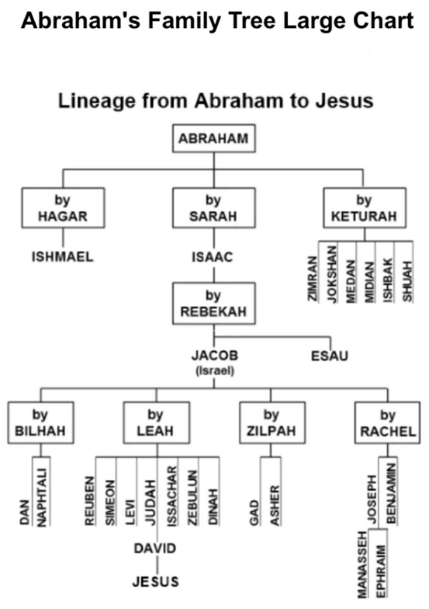
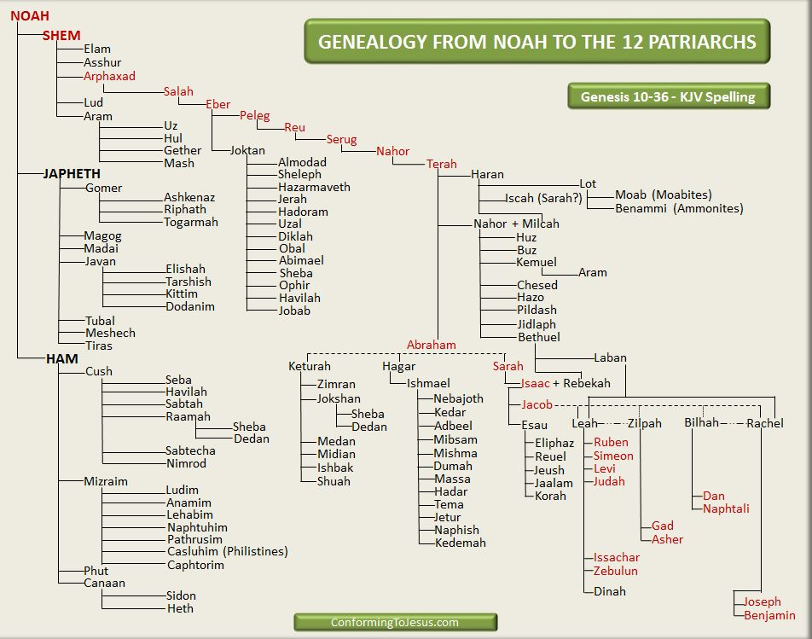
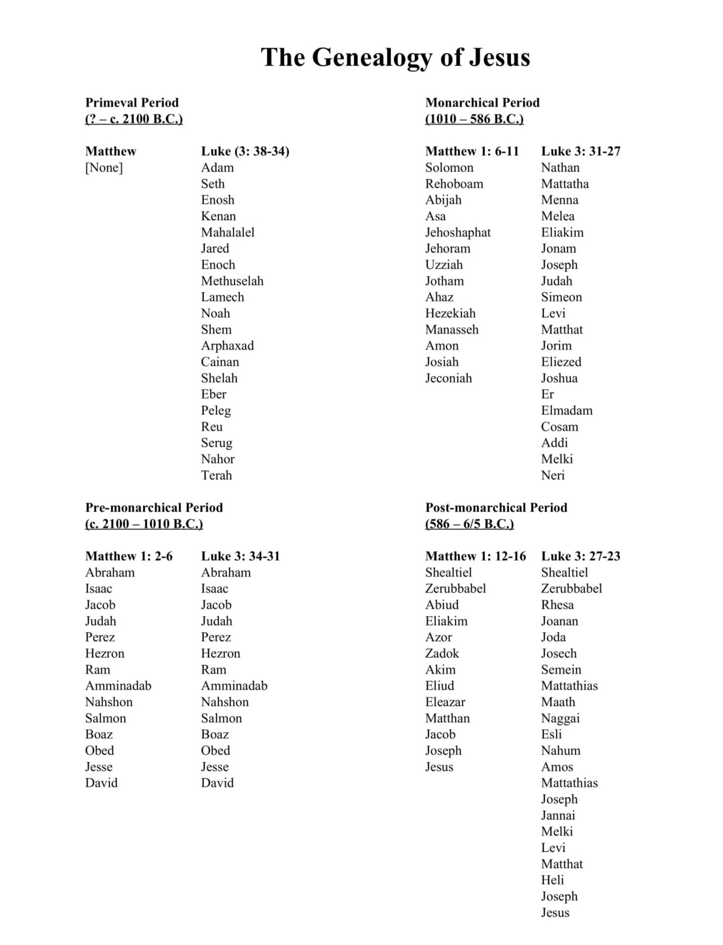
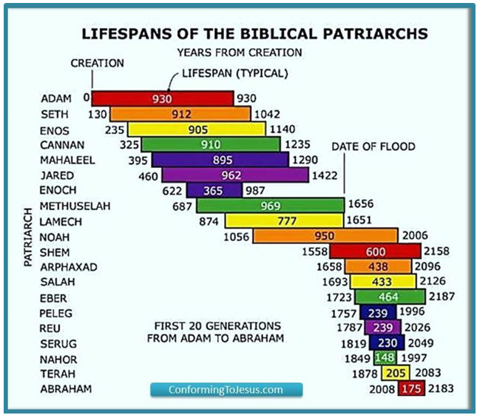

COMPARISON OF GENEAOLOGIES
The following table is a side-by-side comparison of the genealogies found in
Genesis 5&11, Ruth 4, 1Chronicles 1-3, Matthew 1 and Luke 3.
Luke 3 | 1 Chronicles 1-3 | Genesis 5, 11 | Ruth 4 | Matthew 1
God-Jesus | Adam-David | God-Perez | Perez-David | Dynasty
1. God | — | God | — | —
2. Adam | Adam | Adam | — | —
3. Seth | Seth | Seth | — | —
4. Enos | Enos | Enos | — | —
5. Cainan | Cainan | Cainan | — | —
6. Mahalaleel | Mahalaleel | Mahalaleel | — | —
7. Jared | Jared | Jared | — | —
8. Enoch | Enoch | Enoch | — | —
9. Methuselah | Methuselah | Methuselah | — | —
10. Lamech | Lamech | Lamech | — | —
11. Noah | Noah | Noah | — | —
12. Shem | Shem | Shem | — | —
13. Arphaxad | Arphaxad | Arphaxad | — | —
14. Cainan | Cainan | Cainan | — | —
15. Shelah | Shelah | Shelah | — | —
16. Eber | Eber | Eber | — | —
17. Peleg | Peleg | Peleg | — | —
18. Reu | Reu | Reu | — | —
19. Serug | Serug | Serug | — | —
20. Nahor | Nahor | Nahor | — | —
21. Terah | Terah | Terah | — | —
22. Abraham | Abraham | Abraham | — | Abraham
23. Isaac | Isaac | Isaac | — | Isaac
24. Jacob | Jacob | Jacob | — | Jacob
25. Judah | Judah | Judah | — | Judah
26. Perez | Perez | Perez | Perez | Perez
27. Hezron | Hezron | — | Hezron | Hezron
28. Arni | Arni | — | Arni | Arni
29. Amminadab | Amminadab | — | Amminadab | Amminadab
30. Nahshon | Nahshon | — | Nahshon | Nahshon
31. Salmon | Salmon | — | Salmon | Salmon
32. Boaz | Boaz | — | Boaz | Boaz
33. Obed | Obed | — | Obed | Obed
34. Jesse | Jesse | — | Jesse | Jesse
35. David | David | — | David | King of Israel, David
36. Nathan | Nathan, Solomon | — | — | King of Israel, Solomon
37. Mattatha | — | — | — | King of Judah, Rehoboam
38. Menna | — | — | — | King of Judah, Abijam
39. Melea | — | — | — | King of Judah, Asa
40. Eliakim | — | — | — | King of Judah, Jehoshaphat
41. Jonam | — | — | — | King of Judah, Joram
42. Joseph | — | — | — | King of Judah, Uzziah
43. Judah | — | — | — | King of Judah, Jotham
44. Simeon | — | — | — | King of Judah, Ahaz
45. Levi | — | — | — | —
46. Matthat | — | — | — | King of Judah, Hezekiah
47. Jorim | — | — | — | —
48. Eliezer | — | — | — | King of Judah, Manasseh
49. Joshua | — | — | — | —
50. Er | — | — | — | King of Judah, Amon
51. Elmodam | — | — | — | —
52. Cosam | — | — | — | —
53. Addi | — | — | — | King of Judah, Josiah
54. Melchi | — | — | — | King of Judah, Jeconiah
55. Neri | — | — | — | —
56. Shealtiel | — | — | — | Shealtiel
57. Zerubbabel | — | — | — | Zerubbabel
58. Rhesa | — | — | — | —
59. Joannan | — | — | — | Abiud
60. Joda | — | — | — | —
61. Josech | — | — | — | Eliakim
62. Semei | — | — | — | —
63. Mattathias | — | — | — | Azor
64. Maath | — | — | — | —
65. Nagge | — | — | — | Zadok
66. Esli | — | — | — | —
67. Naum | — | — | — | —
68. Amos | — | — | — | Achim
69. Mattathias | — | — | — | —
70. Joseph | — | — | — | Eliud
71. Jannai | — | — | — | —
72. Melchi | — | — | — | Eleazar
73. Levi | — | — | — | —
74. Matthat | — | — | — | Matthan
75. Heli | — | — | — | Jacob
76. Joseph | — | — | — | Joseph
77. Jesus Christ | — | — | — | Jesus Christ

