JESUS QUOTES THE APOCRYPHA IN MATTHEW 23:37

The Geneva Bible and References to the Apocrypha: Jesus Quoting 2 Esdras
1560 edition of the Geneva Bible—the version central to the Protestant Reformation, which the Pilgrims brought to America in 1620, included the Apocrypha. The same is true for the original 1611 King James Bible.
Matthew 23:37 Geneva Bible: Jesus says:
³⁷ Jerusalem, Jerusalem, which killest the Prophetes & stonest them which are sent to thee, how often wolde I have gathered thy children together, as the hen gathereth her chickens under her wings, and ye wolde not! ¹
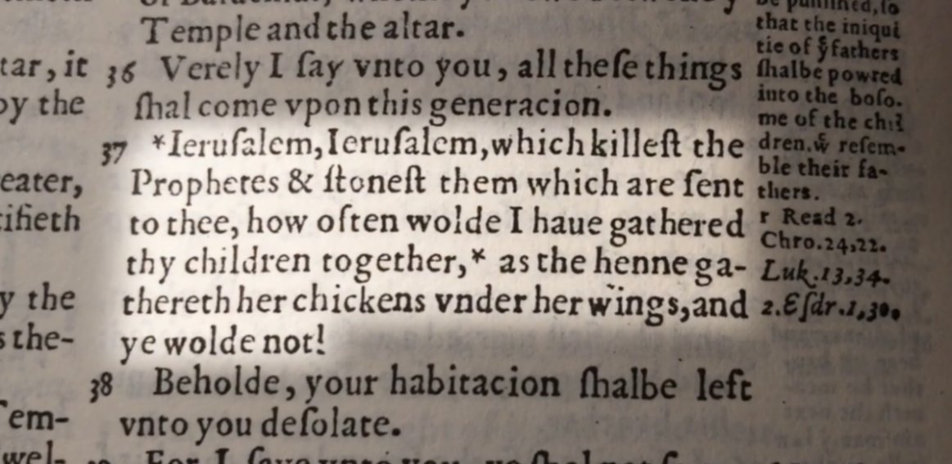

In the marginal note, verse 37 references the Book of 2 Esdras 1:30—an apocryphal book included in the Septuagint, the Greek translation of the Hebrew Bible.
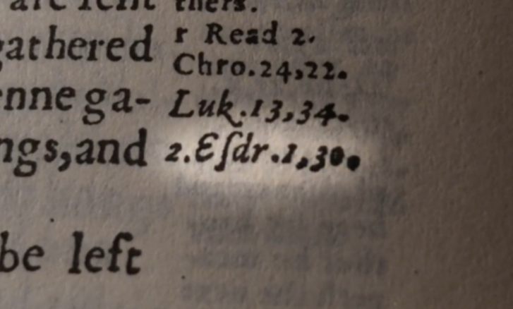

Specifically, it points to 2 Esdras 1:30 KJV
³⁰ I gathered you together as a hen gathereth her chickens under her wings: but now what shall I do unto you? I will cast you out from my face.

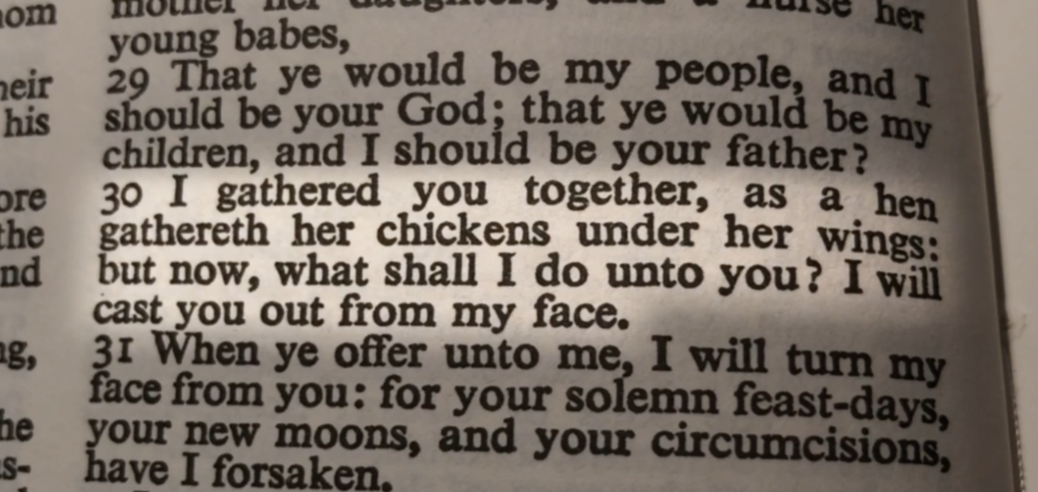

And in 2 Esdras 1:33:
³³ Thus saith the Almighty Lord, Your house is desolate, I will cast you out as the wind doth stubble.

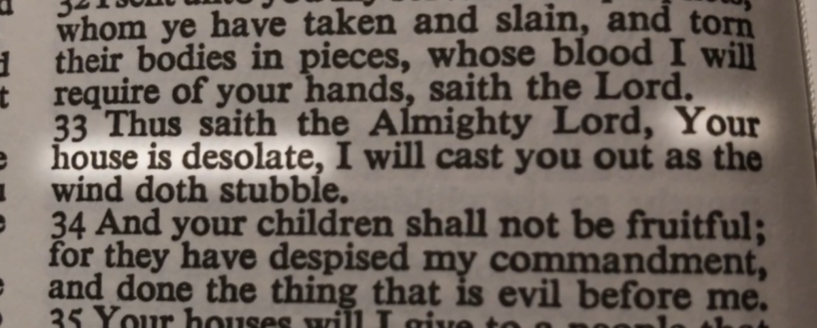

This matches Jesus' words in Matthew 23:37-38 almost exactly:
Matthew 23:37-38 KJV
³⁷ O ºJerusalem, Jerusalem, thou that ^{p}killest the prophets, and ^{p}stonest them which are sent unto thee, how often would I have ^{q}gathered thy children together, even as a hen gathereth her chickens ^{r}under her wings, and ye would not?
³⁸ Behold, your house is left unto you desolate.

It appears that Jesus is quoting directly from 2 Esdras.
In 2 Esdras 7:3 God sends an angel to speak to Ezra [Esdras is the same as Ezra, meaning "help" in Hebrew]

2 Esdras 7:3 KJV
“And I said, Speak on, my God”
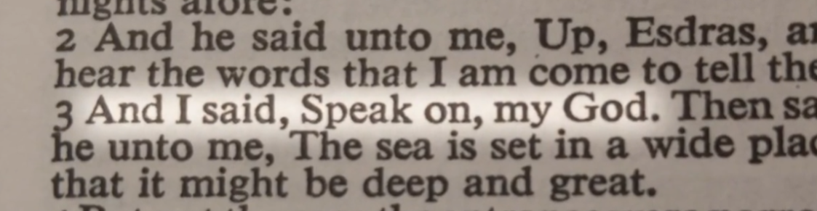

2 Esdras 7:26 KJV says:
²⁶ Behold, the time shall come, that these tokens which I have told thee shall come to pass, and the bride shall appear, and she coming forth shall be seen, that now is withdrawn from the earth. ²⁷ And whosoever is delivered from ºthe foresaid evils shall see my wonders.

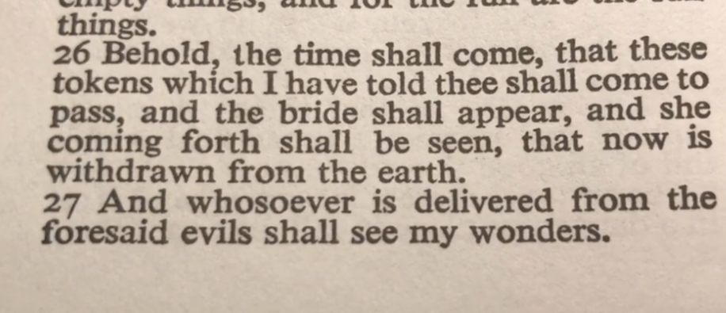
In 2 Esdras 7:28-29 (Ezra lived during the Persian Empire, about 400 years before Christ, around 458-430 BC, after the Greeks defeated the Persians in 330 BC).

2 Esdras 7:28-29 KJV
²⁸ For my son Jesus shall be revealed with those that be with him, and they that remain shall rejoice within ^{p}four hundred years. ²⁹ ^{p}After these years shall my son Christ die, and all men that have life

This is God prophesying to Ezra—400 years before Jesus' birth—that His son, named Jesus Christ, will be revealed and die after those 400 years.
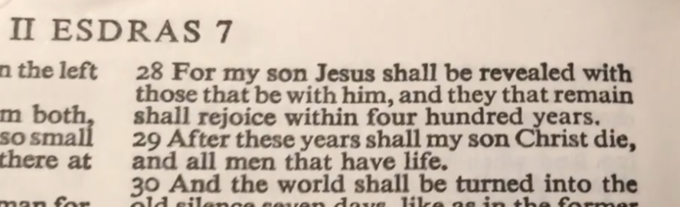

Geneva Bible (Geneva: Rovland Hall, 1560), Mt 23:37.
Geneva Bible (Geneva: Rovland Hall, 1560), 2 Esd 1:30.
Geneva Bible (Geneva: Rovland Hall, 1560), 2 Esd 1:33.
º To ver. 39, Luke 13. 34, 35.
^{p} See ch. 21. 35.
^{p} See ch. 21. 35.
^{q} 2 Esdr. 1. 30. Comp. Deut. 32. 11, 12.
^{r} See Ruth 2. 12.
The Cambridge Paragraph Bible: Of the Authorized English Version (Cambridge: Cambridge University Press, 1873), Mt 23:37–38.
º ver. 20–25.
The Cambridge Paragraph Bible: Of the Authorized English Version (Cambridge: Cambridge University Press, 1873), 2 Esd 7:26–27.
^{p} Comp. Dan. 9. 26.
The Cambridge Paragraph Bible: Of the Authorized English Version (Cambridge: Cambridge University Press, 1873), 2 Esd 7:28–29.

